
User Solutions, Inc.
(800)321-USER(8737)
11009 Tillson Drive
South Lyon, MI 48178
ph: (248) 486-1934 fax: (248)486-6376
www.usersolutions.com us@usersolutions.com

Operations Manager for Excel (C) 1997-2003, User Solutions, Inc.

General Purpose Operations and Manufacturing Management Templates. All materials are COPYRIGHTED. No part of the software or documentation may be reproduced in any form, without express permission from User Solutions, Inc.

Contact US: EMAIL: us@usersolutions.com, PH: (248) 486-1934 FAX: (248) 486-6376

Please visit our website, www.usersolutions.com for information on other flexible and easy-to-use solutions.

Forecasting Section

2.1 Simple exponential smoothing (SIMPLE) 4

2.2 Smoothing linear, exponential, and damped 8
trends (TRENDSMOOTH)

2.3 Introduction to seasonal adjustment 13

2.4 Multiplicative seasonal adjustment 15
for monthly data (MULTIMON)

2.5 Additive seasonal adjustment 18
for monthly data (ADDITMON)

Two demand forecasting models are available in Sections 2.1 - 2.2. The exponential smoothing models extrapolate historical data patterns. Simple exponential smoothing is a short-range forecasting tool that assumes a reasonably stable mean in the data with no trend (consistent growth or decline). To deal with a trend, try the trend-adjusted smoothing model. TRENDSMOOTH lets you compare several different types of trend before committing to a forecast.

The exponential smoothing worksheets accept either nonseasonal data or data which has been seasonally-adjusted using of the models in Sections 2.4 and 2.5. If your data contain a seasonal pattern, perform a seasonal adjustment before you apply exponential smoothing. Seasonal adjustment removes the seasonal pattern so that you can concentrate on forecasting the mean or trend
2.1 Simple exponential smoothing (SIMPLE)

More than 25% of U.S. corporations use some form of exponential smoothing as a forecasting model. Smoothing models are relatively simple, easy to understand, and easy to implement, especially in spreadsheet form. Smoothing models also compare quite favorably in accuracy to complex forecasting models. One of the surprising things scientists have learned about forecasting in recent years is that complex models are not necessarily more accurate than simple models.

The simplest form of exponential smoothing is called, appropriately enough, simple smoothing. Simple smoothing is used for short-range forecasting, usually just one month into the future. The model assumes that the data fluctuate around a reasonably stable mean (no trend or consistent pattern of growth). If the data contain a trend, use the trend-adjusted smoothing model (TRENDSMOOTH).

Figures 2-1 illustrates an application of simple exponential smoothing at the International Airport in Victoria, Texas. The airport has been open for a year and the data are the monthly numbers of passengers embarked. The terminal manager feels that he has enough data to develop a forecast of passengers one month in advance in order to schedule part-time employment for airport parking, baggage handling, and security.

To get the forecasting process started, SIMPLE automatically sets the first forecast (F26) equal to the average of the number of warm-up data specified in cell D9. The number of warm-up data is 6, so the first forecast of 30.0 is the average of the data for months 1-6. If you don't like the first forecast, replace the formula in F26 with a value. Thereafter the forecasts are updated as follows: In column G, each forecast error is equal to actual data minus the forecast for that period. In column F, each forecast is equal to the previous forecast plus a fraction of the previous error. This fraction is found in cell D8 and is called the smoothing weight. The model works much like an automatic pilot, a cruise control on an automobile, or a thermostat. If a given forecast is too low, the forecast error is positive, and the next forecast is increased by a fraction of the error. If a given forecast is too high, the forecast error is negative, and the next forecast is reduced by a fraction of the error. If we get lucky and a forecast is perfect, the error is zero and there is no change in the next forecast.

A total of 12 data observations are entered in Figure 2-1. The model automatically makes forecasts through the last period specified in cell D10. For months 13-24, the forecasts are constant as shown in Figure 2-2. Remember that the model assumes no trend, so the only option is to project the last forecast for every period in the future.

The model computes two mean forecast error measures. The MSE is the mean-squared-error and the MAD is the mean of the absolute errors or the mean-absolute-deviation. Both are commonly used in practice. The MSE gives more weight to large errors, while the MAD is easier to interpret.

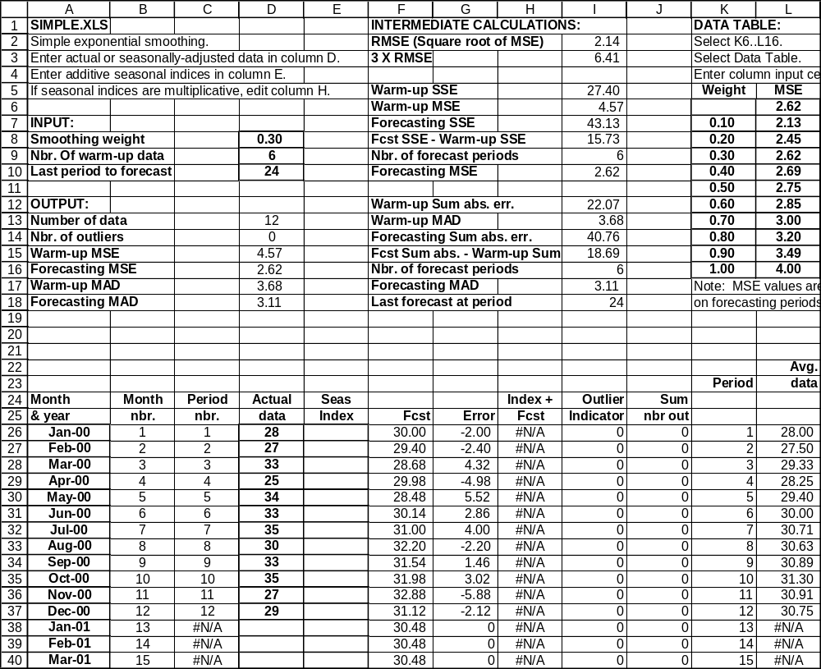
Figure 2-1

Figure 2-2
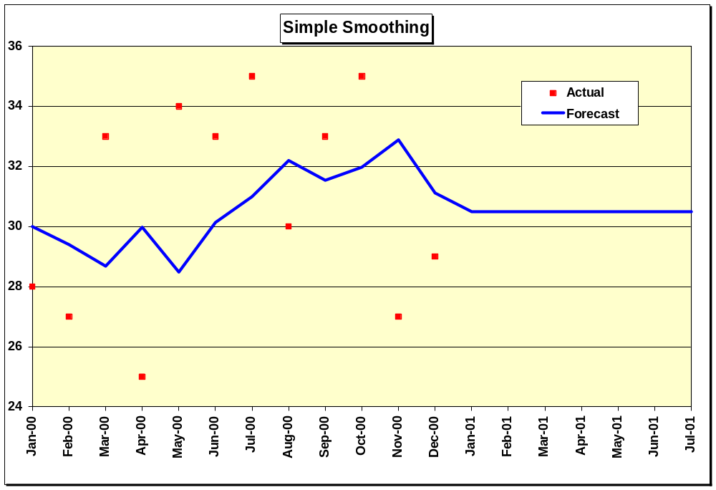

Both MSE and MAD are computed for two samples of the data. The first sample (periods 1-6) is called the warm-up sample. This sample is used to "fit" the forecasting model, that is to get the model started by computing the first forecast and running for a while to get "warmed up." The second part of the data (periods 7-12) is used to test the model and is called the forecasting sample. Accuracy in the warm-up sample is really irrelevant. Accuracy in the forecasting sample is more important because the pattern of the data often changes over time. The forecasting sample is used to evaluate how well the model tracks such changes. There are no statistical rules on where to divide the data into warm-up and forecasting samples. There may not be enough data to have two samples. A good rule of thumb is to put at least six nonseasonal data points or two complete seasons of seasonal data in the warm-up. If there is less data than this, there is no need to bother with two samples. In a long time series, it is common in practice to simply divide the data in half. If you don't want to bother with a warm-up sample, set the number of warm-up data equal to the total number of data. The forecasting MSE and MAD will then be set to zero.

How do you choose the weight in cell D8? A range of trial values must be tested. The best-fitting weight is the one that gives the best MSE or MAD in the warm-up sample. There are two factors that interact to determine the best-fitting weight. One is the amount of noise or randomness in the series. The greater the noise, the smaller the weight must be to avoid overreaction to purely random fluctuations in the time series. The second factor is the stability of the mean. If the mean is relatively constant, the weight must be small. If the mean is changing, the weight must be large to keep up with the changes. Weights can be selected from the range 0 - 1 although we recommend a minimum weight of 0.1 in practice. Smaller values result in a very sluggish response to changes in the mean of the time series.

An Excel data table is available in columns K and L to assist in selecting smoothing weights. Column K displays smoothing weights from 0.10 to 1.00 in increments of 0.10 while column L displays the corresponding forecast MSE. Follow the instructions at the top of the data table to update MSE values. The weights in column K can be changed. You can also edit the formula in L6 to compute MAD rather than MSE results.

Two other graphs in the SIMPLE workbook assist in evaluation of the forecast model. The error graph compares individual forecast errors to control limits. These limits are established at plus and minus three standard deviations from zero. The standard deviation is estimated by the square root of the MSE, called the RMSE for root-mean-squared-error. The probability is less than 1% that individual errors will exceed the control limits if the mean of the data is unchanged. The “outlier” count in cell D14 of Figure 2-1 is the number of errors that went outside control limits. Finally, the MSE graph is a bar chart of MSE values for alternative smoothing weights.

The forecasting model in SIMPLE is based on two equations that are updated at the end of each time period:

Forecast error = actual data - current forecast
Next forecast = current forecast + (weight x error)

A little algebra shows that this model is equivalent to another model found in many textbooks and in practice:

Next forecast = (weight x actual data) + [(1 - weight) x current forecast]

The model in SIMPLE is easier to understand and requires less arithmetic. It is true that the model requires computation of the error before the forecast can be computed. However, the error must always be computed to evaluate the accuracy of the model.

To forecast other data in SIMPLE, enter month and year in column A and data in column D. The data can be nonseasonal or seasonal. If seasonal, enter seasonally-adjusted data in column D and seasonal indices in column E. All forecasts in column F are seasonally-adjusted. The worksheet assumes any seasonal indices are additive in nature, so seasonal indices are added to seasonally-adjusted forecasts in column F to obtain final forecasts in column H. If your seasonal indices are multiplicative rather than additive, edit the formulas in column H to multiply by the index rather than add it. Seasonal calculations are handled in the same way in the TRENDSMOOTH model. Seasonal adjustment procedures are explained in detail in sections 2.3 – 2.5.

2.2 Smoothing linear, exponential, and damped trends (TRENDSMOOTH)

Exponential smoothing with a trend works much like simple smoothing except that two components must be updated each period: level and trend. The level is a smoothed estimate of the value of the data at the end of each period. The trend is a smoothed estimate of average growth at the end of each period.

To explain this type of forecasting, let's review an application at Alief Precision Arms, a company that manufactures high-quality replicas of the Colt Single-Action Army revolver and other revolvers from the nineteenth century. Alief was founded in 1987 and, as shown in Figure 2-3, experienced rapid growth through about 1994. Since 1994, growth has slowed and Alief is uncertain about the growth that should be projected in the future.

Figure 2-3
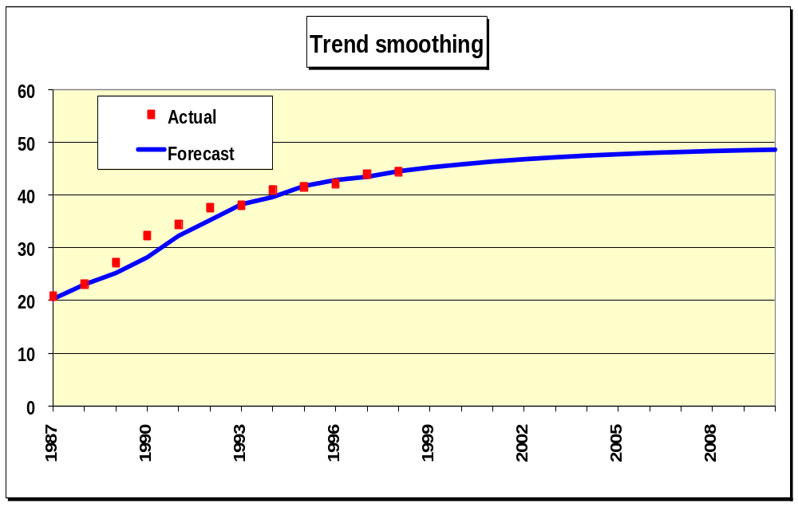

The worksheet in Figure 2-4 was developed to help Alief compare several different types of trend forecasts. This worksheet can produce a linear or straight-line trend, a damped trend in which the amount of growth declines each period in the future, or an exponential trend in which the amount of growth increases each period in the future.

To get started, initial values for level and trend are computed in cells H22 and I22. The model sets the initial trend equal to the average of the first four differences among the data. These differences are (23.1 - 20.8), (27.2 - 23.1), (32.3 - 27.2), and (34.4 - 32.3). The average difference or initial trend is 3.4. This value is our estimate of the average growth per period at the beginning of the data. The initial level is the first data observation minus the initial trend or 20.8 – 3.4 = 17.4.

The forecasting system works as follows:
Forecast error = Actual data - current forecast
Current level = Current forecast + (level weight x error)
Current trend = (Trend modifier x previous trend) + (trend weight x error)
Next forecast = Current level + (trend modifier x current trend)

Level and trend are independent components of the forecasting model and require separate smoothing weights. Experience shows that the level weight is usually much larger than the trend weight. Typical level weights range anywhere from 0.10 to 0.90, while trend weights are usually small, in the range of 0.05 to 0.20. The trend modifier is usually in the range 0.70 to 1.00. If the trend modifier is less than 1.00, the effect is to reduce the amount of growth extrapolated into the future. If the modifier equals 1.00, we have a linear trend with a constant amount of growth each period in the future. If the modifier exceeds 1.00, growth accelerates, a dangerous assumption in practical business forecasting.

Let’s work through the computations at the end of 1987. The forecast error in 1987 is data minus forecast or 20.80 – 20.29 = 0.51. The current level is the forecast for 1998 plus the level weight times the error, or 20.29 + 0.5 x 0.51 = 20.55. The current trend is the trend modifier times the previous trend plus the trend weight times the error, or 0.85 x 3.40 + 0.10 x 0.51 = 2.94. The forecast for 1988 is the current level plus the trend modifier times the current trend or 20.55 + 0.85 x 2.94 = 23.04.

Now look at the forecasts for more than one period ahead. Let n be the number of periods ahead. To forecast more than one period into the future, the formula is:

Forecast for n > 1 = (previous forecast) + [(trend modifier)^n] x (final computed trend estimate)

Let's forecast the years 2000 - 2003, or 2 - 4 years into the future. The previous forecast needed to get started is the 1999 forecast of 45.24. The final computed trend estimate was 0.84 at the end of 1998. The forecasts are:
Figure 2-4
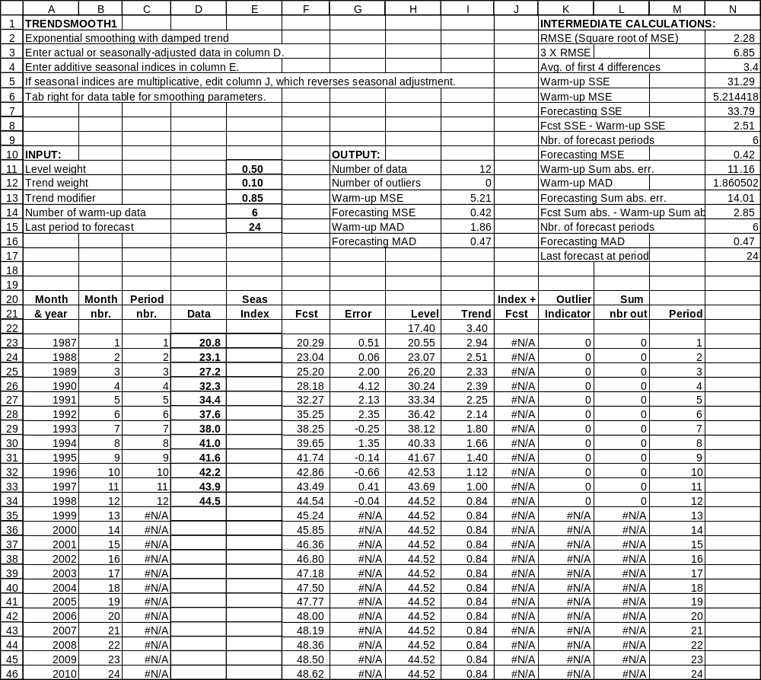
Forecast for 2 years ahead (2000) = 45.24 + .85^2 x 0.84 = 45.85
Forecast for 3 years ahead (2001) = 45.85 + .85^3 x 0.84 = 46.36
Forecast for 4 years ahead (2002) = 46.36 + .85^4 x 0.84 = 46.80
Forecast for 5 years ahead (2003) = 46.80 + .85^5 x 0.84 = 47.18

The trend modifier is a fractional number. Raising a fractional number to a power produces smaller numbers as we move farther into the future. The result is called a damped trend because the amount of trend added to each new forecast declines. The damped trend was selected by Alief management because it reflects slowing growth, probably the best that can be expected given political and economic conditions in the firearms market at the end of 1998. The damped trend approach to the Alief data gives an excellent forecasting MSE of 0.42, much better than the linear alternative. To see the linear trend, change the trend modifier in cell E13 to 1.00. The graph shows growth that runs well above the last few data observations, with a forecasting MSE of 8.09. Optimists can also generate an exponential trend. Set the trend modifier to a value greater than 1.0 and the amount of trend increases each period. This type of projection is risky in the long-term but is often used in growth markets for short-term forecasting.

To reiterate, by changing the trend modifier, you can produce different kinds of trend. A modifier equal to 1.0 yields a linear trend, where the amount of growth in the forecasts is constant beyond the end of the data. A modifier greater than 1.0 yields an exponential trend, one in which the amount of growth gets larger each time period. A modifier between 0 and 1 is widely used because it produces a damped trend.

TRENDSMOOTH requires that you choose the best combination of three parameters: level weight, trend weight, and trend modifier. There are various ways to do this in Excel. The simplest approach is to set the trend modifier equal to 1.0. and use the data table starting at the top of column Q to find the best combination of level and trend parameters, the combination that minimizes the MSE or MAD. Search over the range 0.10 to 0.90 for the level weight in increments of 0.10. Search over the range 0.05 to 0.20 for the trend weight in increments of 0.05. Then fix the level and trend parameters and try alternative values of the trend modifier in the range 0.70 to 1.00 in increments of 0.05. Once you find the best trend modifier, run the data table again, then do another search for the trend modifier. Keep going until the forecasting MSE stabilizes. Great precision is not necessary. TRENDSMOOTH is a robust model, relatively insensitive to smoothing parameters provided that they are approximately correct.

2.3 Seasonal adjustment

Regular seasonal patterns appear in most business data. The weather affects the sales of everything from bikinis to snowmobiles. Around holiday periods, we see increases in the number of retail sales, long-distance telephone calls, and gasoline consumption. Business policy can cause seasonal patterns in sales. Many companies run annual dealer promotions which cause peaks in sales. Other companies depress sales temporarily by shutting down plants for annual vacation periods.

Usually seasonality is obvious but there are times when it is not. Two questions should be asked when there is doubt about seasonality. First, are the peaks and troughs consistent? That is, do the high and low points of the pattern occur in about the same periods (week, month, or quarter) each year? Second, is there an explanation for the seasonal pattern? The most common reasons for seasonality are weather and holidays, although company policy such as annual sales promotions may be a factor. If the answer to either of these questions is no, seasonality should not be used in the forecasts.

Our approach to forecasting seasonal data is based on the classical decomposition method developed by economists in the nineteenth century. Decomposition means separation of the time series into its component parts. A complete decomposition separates the time series into four components: seasonality, trend, cycle, and randomness. The cycle is a long-range pattern related to the growth and decline of industries or the economy as a whole.

Decomposition in business forecasting is usually not so elaborate. We will start by simply removing the seasonal pattern from the data. The result is called deseasonalized or seasonally-adjusted data. Next the deseasonalized data is forecasted with one of the models discussed earlier in this chapter. Finally, the forecasts are seasonalized (the seasonal pattern is put back).

There are two kinds of seasonal patterns: multiplicative and additive. In multiplicative patterns, seasonality is proportional to the level of the data. As the data grow, the amount of seasonal fluctuation increases. In additive patterns, seasonality is independent of the level of the data. As the data grow, the amount of seasonal fluctuation is relatively constant.

Both types of seasonality are found in business data. Multiplicative seasonality is often the best choice for highly aggregated data, such as company or product-line sales series. In inventory control, demand data are often noisy and contain outliers. Thus the additive model is widely used because it is less sensitive to outliers.

In multiplicative seasonality, the seasonal index is defined as the ratio of the actual value of the time series to the average for the year. There is a unique index for each period of the year. If the data are monthly, there are twelve seasonal indices. If the data are quarterly, there are four indices. The index adjusts each data point up or down from the average for the year. The index is used as follows:
Actual data / Multiplicative Index = Deseasonalized data

Suppose the multiplicative seasonal index for January sales is 0.80. This means that sales in January are expected to be 80% of average sales for the year. Now suppose that actual sales for January are $5000. Deseasonalized sales are:

$5000 / .80 = $6250.

To put the seasonality back, or to seasonalize the sales, we use:

Deseasonalized data x Multiplicative Index = Actual data

$6250 x .80 = $5,000.

In additive seasonality, the seasonal index is defined as the expected amount of seasonal fluctuation. The additive index is used as follows:

Actual data – Additive Index = Deseasonalized data

Suppose that the additive seasonal index for January sales is -$1,250. This means that sales in January are expected to be $1,250 less than average sales for the year. Now suppose that actual sales for January are $5,000. Deseasonalized sales are:

$5000 - (-$1,250) = $6,250.

To put the seasonality back, or to seasonalize the sales, we use:

Deseasonalized data + Additive Index = Actual data

$6,250 + (-$1,250) = $5000.

Two worksheets are available for seasonal adjustment. MULTIMON uses the ratio-to-moving average method to adjust monthly data. ADDITMON uses a similar method called the difference-to-moving average method to adjust monthly data. It may be necessary to test both of these worksheets before choosing a seasonal pattern.

2.4 Ratio-to-moving-average seasonal adjustment for monthly data (MULTIMON)

Hill Country Vineyards uses the MULTIMON worksheet in Figure 2-5 to adjust sales of its product line. Champagne sales, as you might expect, peak around the holiday season at the end of the year and fall off in the summer. To get adjusted data in the model, the first step in column E is to compute a 12-month moving average of the data. The first moving average, covering January through December, is always placed next to month 7. The second moving average, for February through January, is placed opposite month 8, and so on. This procedure means that there will not be a moving average for the first 6 or the last 5 months of the data.

The second step is to use the moving averages to compute seasonal indices. If you divide each data point by its moving average, the result is a preliminary seasonal index. Ratios are computed in column F: Each ratio is simply the actual sales in column D divided by the moving average in column E. The ratios for the same month in each year vary somewhat, so they are summed in column G and averaged in column I. The average ratios can be interpreted as follows. Sales in January are predicted to be 73% of average monthly sales for the year. Sales in December are predicted to be 209% of average. For this interpretation to make sense, the average ratios must sum to 12 since there are 12 months in the year. The average ratios actually sum to 12.124 because rounding is unavoidable. Therefore, formulas in column J "normalize" the ratios to sum to 12.

Column K simply repeats the ratios. The same set of 12 ratios is used each year to perform seasonal adjustment in column L. Each actual data point in column D is divided by the seasonal index applicable to that month to obtain the adjusted data in column L.

How do we know that the seasonal adjustment procedure was successful? Cells I6..J6 compute the variances of the original and seasonally-adjusted data, with coefficients of variation (standard deviation / average) in I7..J7. Seasonal adjustment produced a significant reduction in variance, which makes the seasonally-adjusted data much easier to forecast than the original data. The effects of seasonal adjustment are apparent in the graph in Figure 2-6. The seasonally-adjusted line is much smoother than the original data.

Figure 2-5

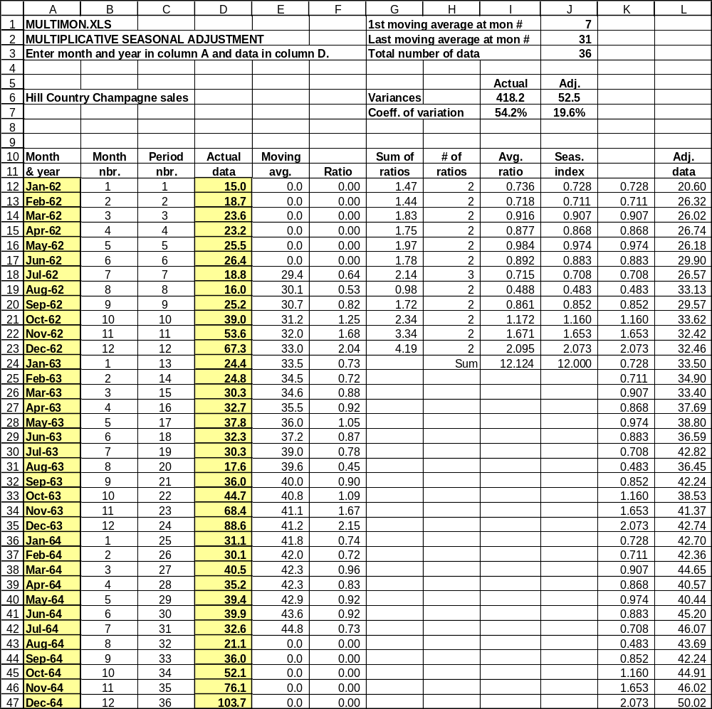

Figure 2-6

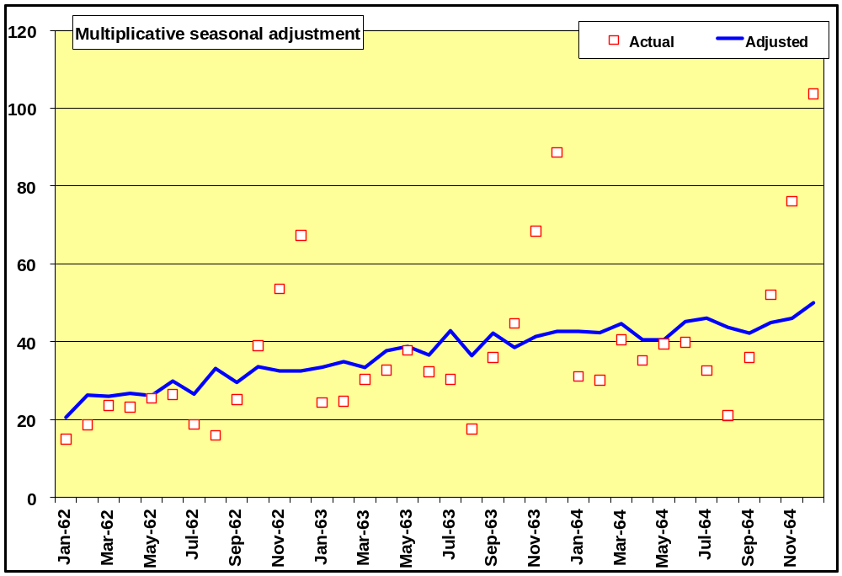

2.5 Difference-to-moving-average seasonal adjustment for monthly data (ADDITMON)

Additive seasonal adjustment for the Hill Country data is shown in Figure 2-7. The procedure is similar to the multiplicative case except that column F contains differences between actual and moving average instead of ratios. The average difference is computed in column I. They should sum to zero but do not because of rounding. To normalize in column J, the average difference / 12 is subtracted from each index. Indices by month are repeated in column K. The adjusted data are then actual data minus the appropriate index.

Additive adjustment does not work quite as well for the Hill County data as did multiplicative. The additive variance for adjusted data is somewhat larger than the multiplicative variance. The reason is that the seasonal pattern appears to be proportional to the level of the data, increasing as the data grow.

In business data, the type of seasonal adjustment that should be used is often unclear. We recommend that you test both procedures and use the one that produces the smallest variances.

To use seasonally-adjusted data for forecasting, copy the adjusted data in column L to SIMPLE or TRENDSMOOTH. Paste the data in column D of the forecasting worksheet using the following selections: Edit Paste Special Values so that values only and not formulas are transferred. Next, use the same commands to copy the seasonal indices in column K of the seasonal adjustment worksheet to column E of the forecasting worksheet.

The original forecasting worksheets are set up for additive seasonality (column H of SIMPLE and column J of TRENDSMOOTH). If seasonal indices were produced in ADDITMON, no editing is necessary and these columns will contain the final forecasts after seasonalizing, that is putting the seasonal pattern back. If seasonal indices are multiplicative from MULTIMON, you must edit the formulas in column H or J of the forecasting worksheet so that the deseasonalized data are multiplied by the indices.

Figure 2-8 shows TRENDSMOOTH after the multiplicative-adjusted data have been transferred and forecasted. The forecast column contains seasonally-adjusted forecasts, while the Index * forecast column contains the final forecasts.

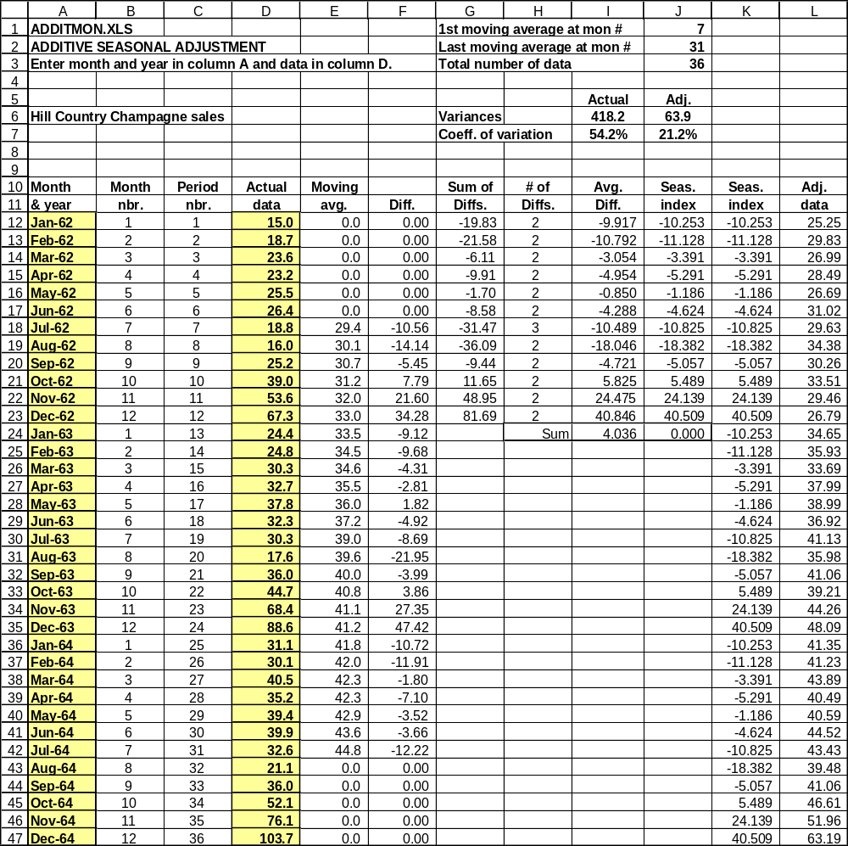
Figure 2-7

Figure 2-8
